MODEL 800 ADAPTORS

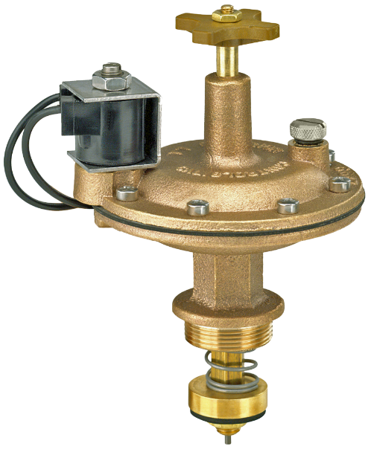

- WILL NOT SHUT OFF
  - Check for foreign object at bottom of solenoid cavity.
  - Check seat of solenoid plunger to see if there is anything embedded in it.
  - Check solenoid plunger to see if it is free moving. Clean as necessary.
  - Check spring on solenoid plunger to see if it is on properly. Replace if necessary.
  - Open manual bleeder. If no water comes out then remove adaptor from valve body and check for clogged inlet orifice at bottom of shaft (at center of seat disc).
  - Remove adaptor from valve body and check for debris under seat disc as well as damaged seat disc. Replace if necessary. Also check seat in valve body for rough edges or debris.
  - If there is excess back pressure in system, which can be caused by an insufficient number of heads for the volume of water passing thru the valve, it may be necessary to balance the system in order for the valve to shut off.
    - Turn flow control clockwise a half turn at a time until slightly less water is passing out the heads.
    - Turn flow control counter clockwise a half turn so that the same amount of water is passing out the head as just before it decreased slightly.

- WATER WEEPS PAST VALVE SEAT
  - Remove adaptor form valve body and check for debris in seat disc and/or roughness in seat of valve body. Replace disc seat if necessary.
  - Attempt to turn seat disc in clockwise direction. If the shaft turns as you turn the seat disc, do the following:
    - Remove cap screws or bolts.
    - Separate diaphragm cap from the rest of the adaptor. Take care not to bend the cleaning rod which is attached to the diaphragm cap.
    - Tighten the nut located at the top of the shaft.
    - Reassemble adaptor. Be sure that everything is tight, including the nut at the bottom of the shaft.
  - If there is no seat impression in the seat disc, or a slight irregular impression, the seat of the valve body is too low requiring that a stainless steel spacer be added to the shaft as follows:
    - Remove nut at bottom end of shaft.
    - Remove disc and disc holder from shaft.
    - Do not remove the fiber washer that sits above the disc holder.
    - Add a stainless steel washer (spacer) to the shaft and add an additional fiber washer so that the stainless steel spacer is sandwiched between the two fiber washers. On certain models, there may already be a stainless steel spacer on the shaft. If so, add a second washer next to the washer already on the shaft. Be sure that there is a fiber washer on both sides of the washer(s).
  - A tear in the diaphragm can cause weeping but this is an uncommon cause.

- VALVE WILL NOT OPEN
  - Check to see if solenoid is receiving power as follows:
    - Energize solenoid at the controller. The solenoid should vibrate enough that is can be felt when coil is touched.
    - As an additional check, remove coil and solenoid assembly from diaphragm cap making sure that the plunger does not fall from the hollow tube of the stem. Have another person energize the solenoid at the controller. Plunger should be sucked up into the tube portion of the stem.

If the solenoid is not receiving power, the most likely cause, assuming the controller is functioning properly, is a damaged valve wire. Another possibility is a bad coil.
  - Check for clogged exhaust port.
    - Remove adaptor from valve body.
    - Unscrew cap screws on bolts and separate diaphragm cap from adaptor taking care not to bend cleaning rod which is attached to upper diaphragm cap.
    - On the diaphragm, there are holes for each cap screw or bolt plus an extra hole that must be centered over the exhaust port. If the adaptor was recently taken apart, its possible that the diaphragm was not aligned properly when the adaptor was reassembled. If the extra hole was not directly over the exhaust port, the valve will not open.
    - Check exhaust ports in upper and lower diaphragm caps for obstruction.
  - Check to see if metering rod is missing.
  - Check to see if inlet port at bottom of shaft is oversized. Corrosive water, over a period of time, can enlarge the inlet orifice which causes water to enter chamber above diaphragm faster than it can escape thru exhaust port.
  - Too much elevation can cause valve not to open. Consult factory regarding 3-way solenoid valve to correct problem.

- WATER LEAKS OUT FLOW CONTROL STEM
  - Shut off water supply to valve.
  - Remove cap screws or bolts and separate diaphragm from the rest of the adaptor taking care not to bend the cleaning rod which is attached to the cap. It is not necessary to remove the adaptor from the valve body.
  - Remove flow control cross handle.
  - From underneath the diaphragm cap, unscrew the flow control stem so that it drops down from the cap.
  - Replace the flow control 0-ring and reassemble valve.
  - Turn on water supply to valve.

